DESIGN AND ACCESS STATEMENT

Proposed xx Storey Extension at:

Your address here
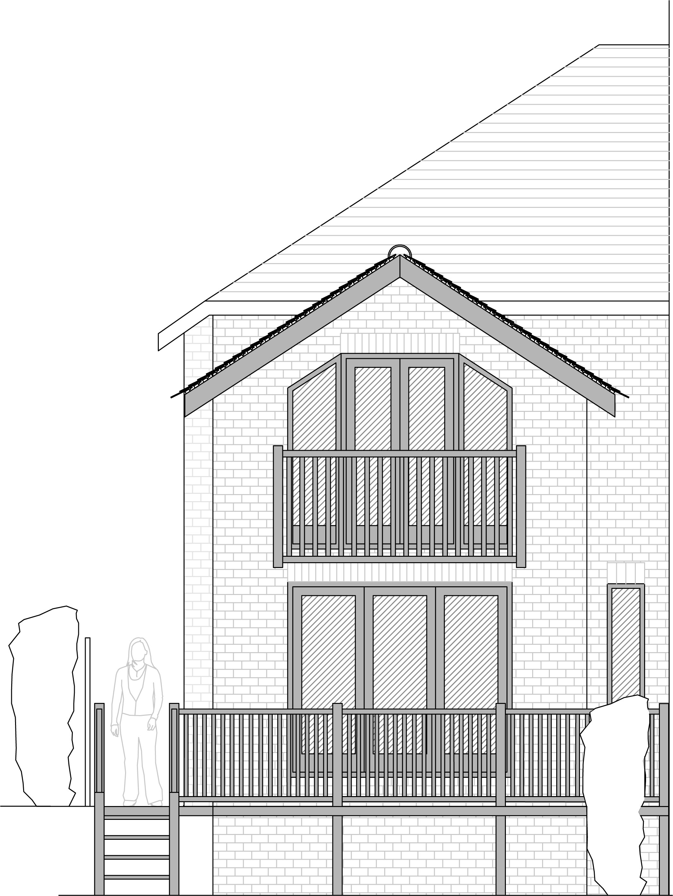

Design and Access Statement:

This letter accompanies the Planning Application for a two storey extension which will replace an existing single storey kitchen.

As agents for the owner – Mr ?? – we would ask you to consider the following: - delete if you are the home owner

The existing property was originally a two-bedroom dwelling with a small kitchen large enough for only one person to comfortably work in. The second bedroom was then divided into two rooms to suit a larger family whilst the small kitchen remained. – a brief description of the existing property
The garden to the rear of the property is approximately 120 feet in length and is out of scale to the house by modern standards. This lends itself perfectly to increasing the size of the dwelling without compromising outdoor life. – In this case there is a large garden, give an explanation of how easy it will be to extend the house
The proposed extension will not only provide a modern sized kitchen in keeping with the rest of the house but will also convert the house into a true three-bedroomed property providing an important second double bedroom. – explain the benefit of extending
The extension has been designed sympathetically to minimise the impact on the neighbouring properties. No windows will be installed on the Northern elevation so as to protect the privacy of the neighbour who already has a window facing West and no upper-floor windows except for two roof-lights will be installed on the Southern elevation so the neighbours garden will not be overlooked. – explain how the extension has been designed to protect the neighbours privacy
No changes to the access of the site are proposed and the extension should not affect properties in the front of the boundary. – will the proposal affect the street access, new gates, etc? If new access is proposed, details should be provided to explain the benefits of, and how any issues have been addressed
You will see from the photograph below that many of the properties in the area have already been extended and so this addition will not look out of place in the busy line of properties. We have also shown a view of the rear of the property showing the level drop which shows the scale of the existing building of which the proposal is designed to be significantly incidental to. – add photos to show any precedent, you can see below that other houses in the street have extended

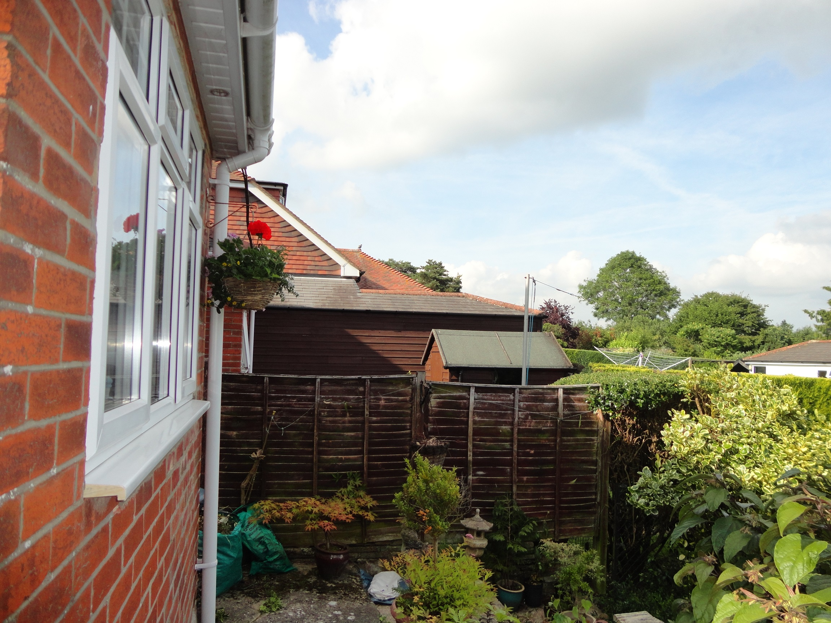

The design of the proposal will feature a timber-framed internal structure and brick exterior along with slates to match the existing property. Existing materials will be re-used where possible to minimise the impact on the environment. – detail the materials to be used and also suggest any environmental / energy savings too
The vaulted ceiling in the upper floor has allowed us to keep the ridge height as low as possible whilst maintaining a well-proportioned room within. – thinking about the neighbours again
The use of a timber frame will reduce the time spent on site constructing the building as the frame will be pre-cut at the manufacturer shipped to site as a kit. This will reduce the noise pollution associated with construction projects and also allow the project to be completed faster.
If we can provide any further details or material samples please do not hesitate to contact us

Yours sincerely

